

***CSS Essentials***

**Assignments**

|  |  |
| --- | --- |
| Document Code | 25e-BM/HR/HDCV/FSOFT |
| Version | 1.1 |
| Effective Date | 20/11/2012 |

**Hanoi, 04/2019**

RECORD OF CHANGES

|  |  |  |  |  |  |
| --- | --- | --- | --- | --- | --- |
| No | Effective Date | Change Description | Reason | Reviewer | Approver |
|  | 25/Jun/2018 | Create a new Lab | Create new | DieuNT1 | VinhNV |
|  | 01/May/2019 | Update Fsoft Template | Update | DieuNT1 | VinhNV |
|  |  |  |  |  |  |
|  |  |  |  |  |  |
|  |  |  |  |  |  |
|  |  |  |  |  |  |
|  |  |  |  |  |  |
|  |  |  |  |  |  |
|  |  |  |  |  |  |
|  |  |  |  |  |  |

Contents

Unit 7 – Sizing Items 4

Objectives: 4

Project Structure 4

Problem 1: 4

Problem 2: 5

Problem 3: 5

|  |  |
| --- | --- |
|  | **CODE: CSS-E.M.A701**  **TYPE: Medium**  **LOC: N/A**  **DURATION: 60 MINUTES** |

# Unit 7 – Sizing Items

Objectives:

* Understand some of values a units in Sizing items in CSS

Project Structure

* A project called **CSS-E.M.A701** (this will be your root folder) is provided to you
* Put your work for each problem in corresponding folder inside root folder

Problem 1:

In this task, you have two boxes. The first should be sized so that the height will be at least 100 pixels tall, even if there is less content than would cause it to grow to that height, however, the content should not overflow if there is more content than fits in 100 pixels. Test this box by removing the content from the HTML to make sure you still get a 100 pixel tall box even with no content.

The second box should be fixed at 100 pixels tall, so that content will overflow if there is too much.

You can find conversions for the hex color at [this link](https://convertingcolors.com/hex-color-86DEFA.html). You need to figure out how to use the values in CSS.

Expected output:

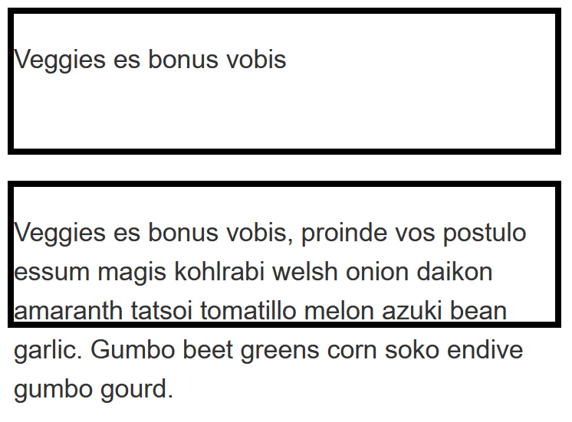

Problem 2:

This task has a box, which contains another box. Your task is to make the inner box 60% of the width of the outer box. The value of the box-sizing property is set to border-box, which means that the total width includes any padding and border. You should also give the inner box padding of 10% using the width (or inline size) as the size from which that percentage is calculated.

Expected output:

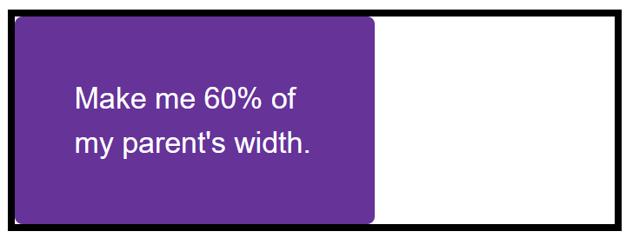

Problem 3:

This problem has two images in boxes. One image is smaller than the box, the other is larger and breaking out of the box. If you imagine that the box is reponsive and therefore could grow and shrink, which property would you apply to the image so that the large image shrinks down into the box but the small image does not stretch.

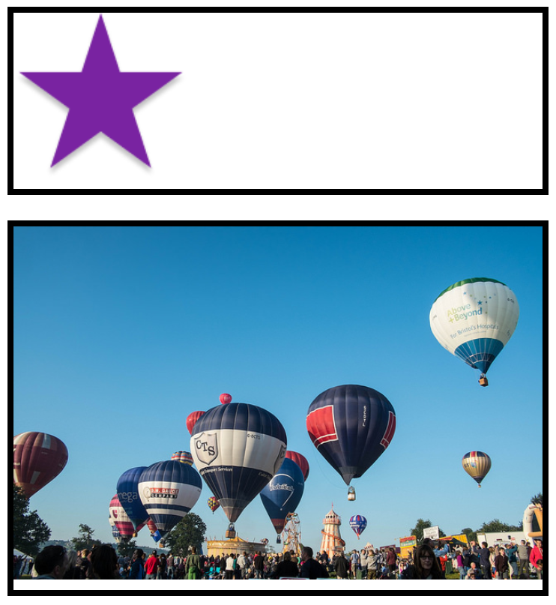

**-- THE END --**